3y BI 15 Genetik v2 – mere om samspil mellem gener 30. oktober 2017

Krydsningsskemaer anvendt til at forudsige hundes pelsfarve – og helbred!
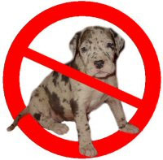
 | Blue merle / Lysegrå grundfarve med gråblå-sortblå pletter

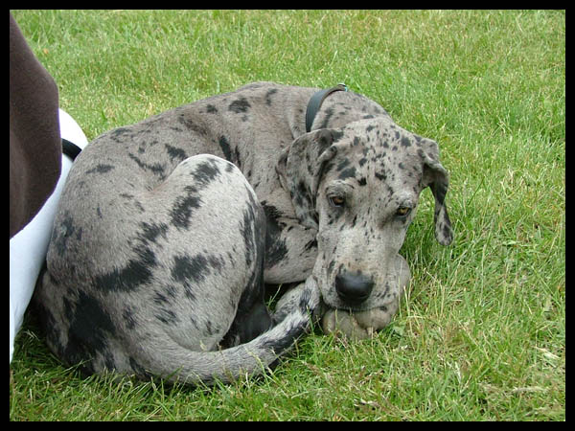

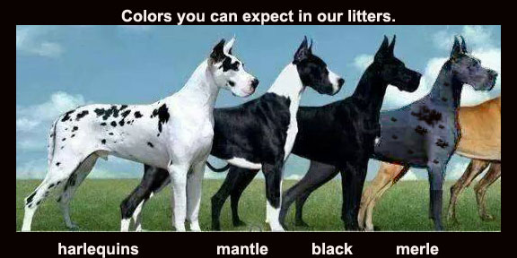

Merle as beauty mark
Imagine a solid color dog—usually black or brown—splashed with bleach. The result would be lighter color patches, often called blue by dog fanciers, on the base coat. Many popular breeds have merle patterning—Australian shepherds, coolies, Shetland sheepdogs, collies, Cardigan Welsh corgis (the ones with tails), Pyrenean shepherds, and Catahoula leopard dogs. Dachshund breeders call merle patterning “dappling.” And the merle gene, Clark says, is involved in creating the harlequin pattern on Great Danes.
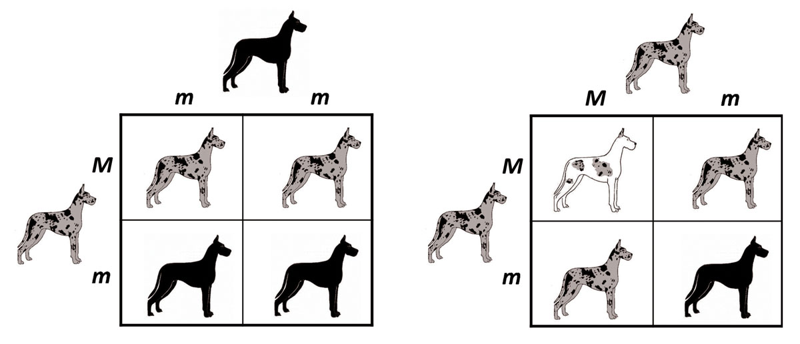
(Figurtekst) Geneticists use Punnett squares (named for Reginald Punnett) to determine the probability of offspring having a particular genotype. In the Punnett squares above, a capital M denotes merle as the dominant allele, and a lowercase m denotes the recessive non-merle allele. Non-merle dogs are depicted in black, but they could have any coat color or pattern other than merle. The squares above show the expected outcomes from a merle-to-non-merle mating (left) and merle-to-merle mating (right). The latter may result in white progeny with sensory defects.

Many dog owners see merle as a beauty mark, distinctive and random, and they are willing to pay more for merle dogs. Uneducated or unscrupulous breeders mistakenly think that crossing merles with merles will increase the likelihood of a litter of merles. This approach may cause more pain than profit.
Responsible dog breeders certainly want to sell pups, but not at the price of a dog’s health. They avoid merle-to-merle mating, which can produce double merles—those receiving the dominant variation from both parents. Double merles are mostly white and can have defects in hearing and vision.
Unfortunately, some merles are hard to detect.
“A dog can be a ‘cryptic’ merle, which shows only small merle patches or no pattern at all and looks like a non-merle,” Clark says. “If a cryptic merle is mated with another merle, one in four of the puppies will be a double merle and at risk for deafness and blindness.”
Double merles have been compared with humans who have Waardenburg Syndrome 2. Both groups have a genetic disorder that hampers the growth of pigment cells, which play a role in development of eye shape and color and the nerve endings in the inner ear. The results often are distinctive soft blue eyes and deafness. In humans, a stark white forelock also can be the calling card of the syndrome.
“There’s no cure for Waardenburg syndrome, but the work will help researchers identify the genetics guiding it, which can alert genetic counselors and dog breeders to look for the problem during DNA screening,” Clark says.
Merle figures into another topic of Clark’s research, the harlequin pattern found on Great Danes. The pattern is the bold black-and-white look that is accepted as part of the breed standard, which includes black, brown, and brindle coloring as well. The Great Dane Charitable Trust has funded her work to identify genetic mechanisms that produce the harlequin pattern. She has worked on the harlequin genetic factor since 2005.
“All harlequins are merles, but they are more than merle,” says Clark. “There’s a separate gene for harlequin. It is a dominant modifier of merle that removes the dilute pigment, leaving the background white.”
In other words, the harlequin gene acts as a stronger bleaching agent, eliminating the merle’s light bleach spots on the base coat, resulting in white base-coat spots.
Kilde: Uddrag fra artiklen: ”Genetics and the coat of many colors” af Peter Kent, som bl.a. citerer genetiker Leigh Anne Clark. URL: http://glimpse.clemson.edu/genetics-and-the-coat-of-many-colors/ Artiklen er uden datering, men hjemmesiden er copyright Clemson University 2017. Downloadet d. 26. oktober 2017.

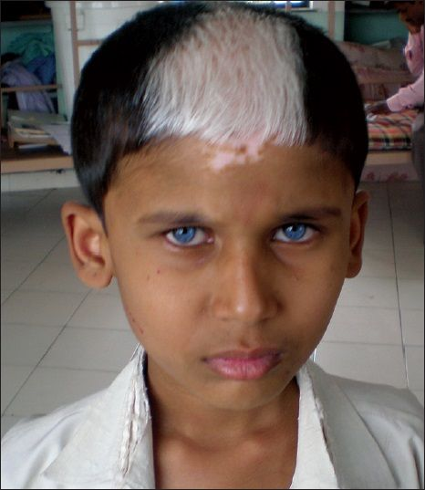 Dreng med Waardenburg Syndrom (web foto)

